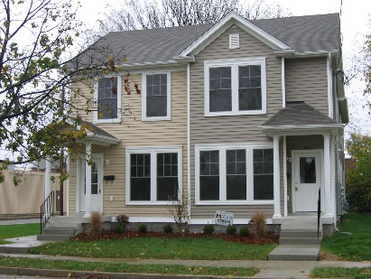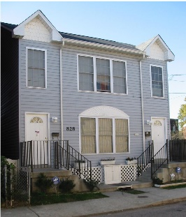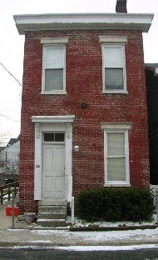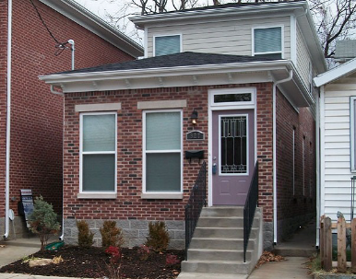

Choices Inc. Annual Report
Fiscal Year: January 1 – December 31, 2020

Mission
Choices, Inc. is creating a place to call home for homeless women and families built on hope, opportunity, motivation and empowerment (HOME).

Organizational Goal
Our goal is to provide the homeless community of Louisville, KY with a permanent supportive housing program which enable residents to address the issues that aggravate and perpetuate their homelessness. We encourage each resident, upon completion of the program, to move into permanent or stable housing with the skills needed for an independent, healthy lifestyle. A good way to think of Choices is that we are the "end of homelessness" for the women and families who successfully meet our program requirements.

Because of your Support
Not many not-for-profits can say 2020 was a great year. In fact, for most non-profits this year has been a real struggle. The reason for this was due to individual donations were way down due to the economic uncertainty. This fact held true for Choices as well. Our saving grace was our relationships with many local foundations who saw the problem and reached out to help. Choices was able to operate in 2020 under a balanced budget of $233,980 and our Dunn & Bradstreet rating continued to get stronger. Additionally, we became a Better Business Bureau (BBB) Accredited Charity and Received a Gold Seal of Transparency from Guide Star, the most respected non-profit watch dog entity.

2020 had another word associated with it for Choices and surprisingly that word was “growth.” Thanks to a generous donation by the Gheens Foundation, Choices purchased a piece of abandoned property at auction which once refurbished will become a new four-bedroom single family home. This isn’t the only growth we saw in 2020 either. In January, we saw our first family to occupy our other West Louisville property which was made possible by New Zion Baptist. This is a beautiful three-bedroom home which was fully furnished for this family.

So many foundations have stepped forward to help “create a place to call home” for so many families this year. The Kentucky Colonels, The Gheens Foundation, The Irvin & Alice Etscorn Foundation, and Delta Dental, just to name a few stepped forward to help renovate our existing units, put new roofs on all of our units, all new appliances, even matching funds for Case Management and Life Skills education for our families but there is still a lot of work yet to do and many families still waiting for permanent supportive housing….

What is important to remember about this year?
2020 bought in serious challenges. The COVID-19 pandemic as everyone knows created economic uncertainty for most of the year. This had its effects on Choices’ budget but the real impacts were felt by our residents who were quarantined in their homes due to the virus in their families. Services still needed to be provided and quarantine brought additional needs that required creative solutions. Additionally, governmental restrictions and mandates impacted our residents as many government and service related entities were either working remotely or were shut down. Public Transportation and shopping became restricted and needed supplies such as paper goods could not be found.

Then came the Civil Unrest in Louisville. Several times the local authorities communicated that, “if you don’t have to come to downtown Louisville, please avoid this area.” This was an impossible task for those living in this area. Parades of protestors came right down their streets daily, sometimes only feet from their front doors, their children. Once again, public transportation was shut down in the area, this time families couldn’t even walk to the store or to appointments for concerns over safety.

Case management and education for Choices team also became a challenge. Remote Case Management was conducted regularly to assess the resident’s needs along with a new form of Life Skills education, “Life Hacks in a COVID world” became necessary.

Our Vision
Our Board and Staff have made the commitment to make our organization grow. We have a goal to acquire one to two additional housing units per year for the next two years. This is not an easy task but with the help of our supporters, we can do it.

Impact
We have made great strides this past year. New roofs and appliance are now on all our units. We maintained 100% occupancy till August when Mrs. B (discussed below) moved out. We have assisted ten families to break the chains of homelessness. Many of these families have become self-sufficient and ready to move and become contributing members of our society once again. So let us tell you about Mrs. B.

Ms. B was referred to Choices in 2018 and was the single mother of four boys. She had a severe mental health diagnosis and two of the boys did as well. When she entered the program she had left the boys’ father, her husband, and was fleeing from domestic violence. She had been a military wife for many years and she and the boys tried to hide their abusive situation for a very long time until they could no longer contain it.
Ms. B and the boys became part of the Choices family. In the first month they were linked to necessary, stable resources and began receiving assistance for multiple needs, such as mental health counseling, health care, food, and more. For the next two years they utilized a number of services and supports and worked hard on making themselves whole as a unit again. In 2020, Ms. B married a wonderful man that the boys had come to love. This man was self-employed, financially stable, and Ms. B was able to join him not only in marriage but in employment. Ms. B became Mrs. H and they moved from our program to a beautiful home in Bullitt County, KY. The boys are in well-reputed schools now in that district and they are living as a family, demonstrating self-sufficiency and independence. Mrs. H said on several occasions that “Without Choices I don’t know where we would be today. I don’t think we would have made it.”

We desperately need your help now more than ever
We cannot grow without your help. In the coming year we have a house that needs to be completely refurbished and we would like to pick up another house as well but we can’t do that without your generosity. Could you help with a financial gift? Maybe you would like to volunteer to help revitalize a unit or property. Maybe you would like to remember Choices in your final arrangements. However you chose to get involved, we need you now more than ever. Just take a drive around downtown. You will see camps of homeless waiting for someone to offer them a hand up, not just a hand out. We can be your hand that helps them, your arms that hug them, and your voice that says, “Welcome to your new home.” Please help us make a difference right here in Louisville.

Financial Summary

Total Revenue $220,222
Total Expense $203,233

Total Fundraising Expense $2,868
Total Administrative Expense $137,370

Total Assets $547,482
Total Liabilities and Equity $547,482

